Fiction Planning and Writing pages
(Always remember, you can change the 2 characters, setting, and problem if you have a great idea of your own!)

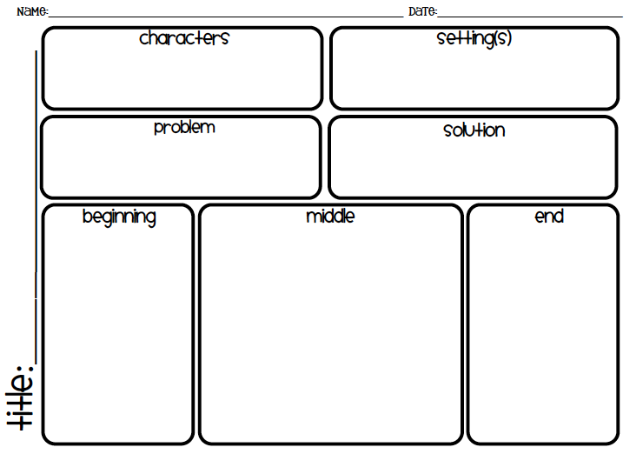

a giant forest
a bear

find a spaceship

