How to start your story…

You can start your story by doing one of these…

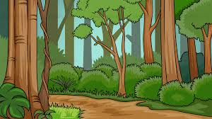
1: Describing the setting.
Example: I was balancing between three branches at the top of an old oak behind my house. I could see over the rooftop. Overhead, planes lined up in the sky, heading towards the airport to land one by one.
Or
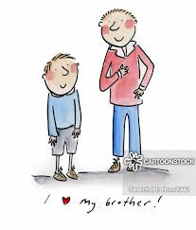
2: Describe something or someone.
Example: Tommy's my little brother, and he's in the first grade. He's fearless. One day, he wore a cape to school. I told him everyone would laugh at him. The next day, five other boys came wearing capes.
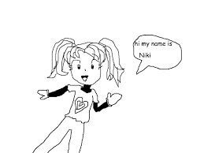
or

3: Be the main character introduce yourself.
Example: I'm Tabitha. I just turned 10, and I'm here to tell you a secret.
or

4: Ask a question.
Example: Why does trouble always follow me around? It’s like I’m a magnet for anything that could go wrong.
or
5: Begin with action or dialogue.
Example: "On your mark! Get set! Go!” yelled the starter official. I launched myself forward, trying to spring ahead of the pack.
or
6: Start with a strong emotion or exclamation.
Example: Ouch! That hurt!

