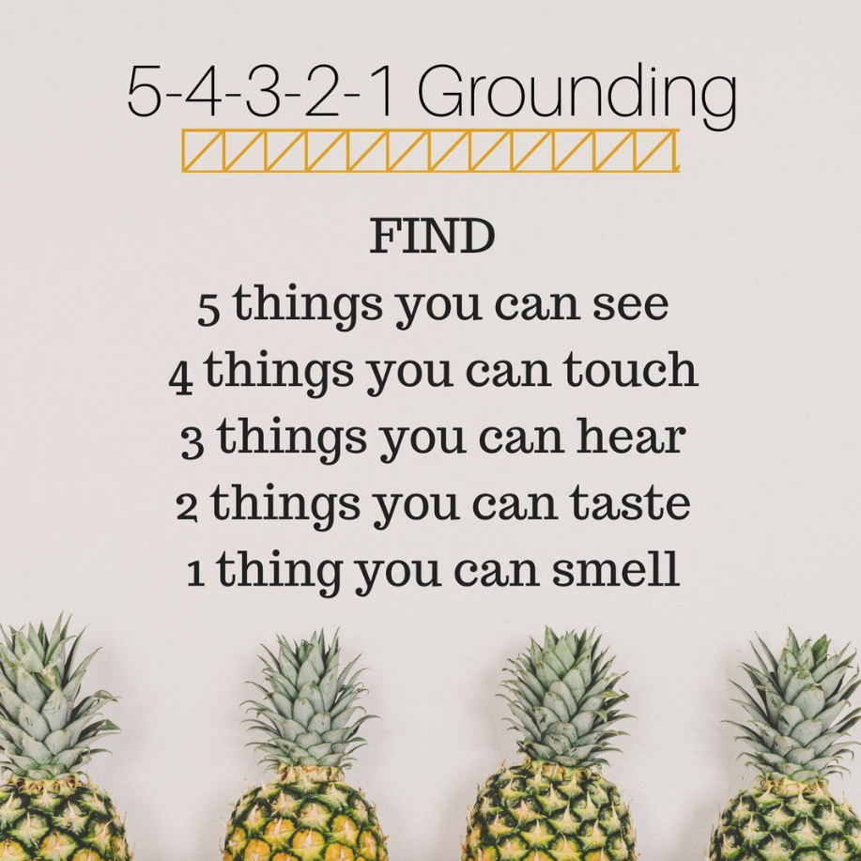
Mindfulness activity:
Sit down outside or inside for this one. Use your senses to become very aware of your surroundings.

