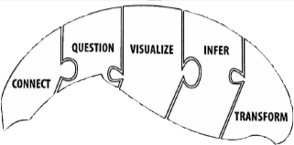
What makes us good readers? Our reading powers!
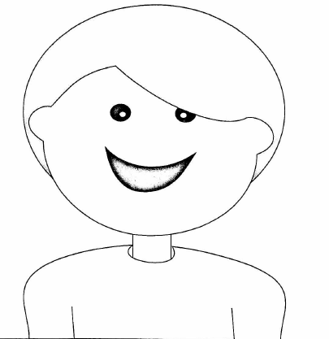

Do you remember what we covered this year, so far? Here’s a reminder.

Connect “This reminds me of…?” Connections from text-to-text, text-to-self, and/or text-to-world

Question “I’m wondering…? Quick questions (answers in the book)
Deep-thinking questions (answers not directly in the book)

Visualize “I can see a picture of what I’m reading, in my mind, and explain it to you or draw it.”

Infer “Maybe this is what is happening or is about to happen based on what I read.”
(Remember our O.W.I. pictures: observe, wonder, infer…mouse on toad’s back in water…?)

This is where we left off before we switched to home learning! The last one left is…

Transform “My thinking has changed after I read this story. I used to think … but now I’m thinking…”
For example, when you read a book about a time in history or an act of kindness, it may
change the way you think. Transformed thoughts. Kind of like a transformer car/robot toy, if
you know what those are.

