Make Someone Smile Sign Design!

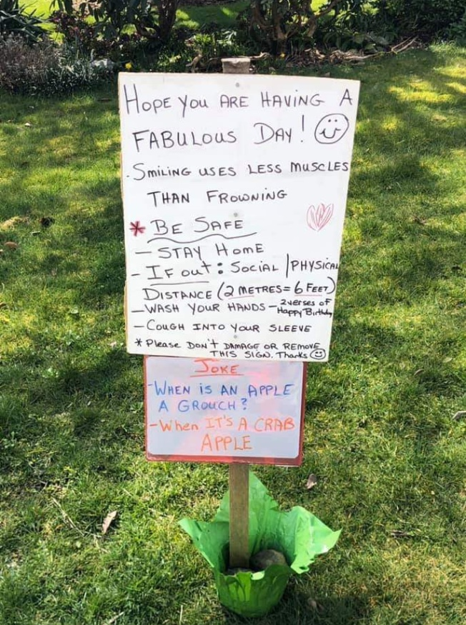

A friend of mine was out for her walk and noticed this sign on a boulevard. It made her smile and lifted her spirits during this time of social isolation. The creator of the sign changes the joke every week! Design and create a sign/poster to share a positive message during this time and make people smile. It could be a message of gratitude for health care workers and/or essential service workers. It could be a positive message for people who are out walking or riding their bikes with a reminder about being safe, like the example shown. You may choose to hang this in your window, stake it in your front yard, or find another space to display it. The purpose of this learning task is to make people smile, share an important message, and/or show our thanks and appreciation for those who are keeping our community safe and healthy! Please e-mail me a picture of your finished sign/poster! I will compile a collage of our signs. Feel free to work on your sign collaboratively with your family!

