Water Cycle in a Bag

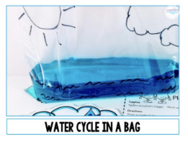
Materials needed:

• a large zip-lock bag
• water
• blue food colouring (optional)
• permanent marker (like a sharpie)
• strong tape, like packing tape
• a sunny window

Directions:
- Draw a model of the water cycle on the outside of your bag.
- Add water up to about the 5 cm mark, from bottom.
- Add blue food colouring now, if you have some.
- Seal the bag. Make sure it is totally shut! (If you REALLY want to be sure, you can tape the top edge of the bag shut after it’s been sealed.)
- Tape the bag to a sunny window with a strip of strong tape, along the top of the bag.

Explanation:
The plastic bag prevents the evaporating water from escaping. It allows the 3 basic processes of the water cycle to take place in a small, observable space. As the sun warms the bag, some of the water heats up, turns into water vapour, and evaporates. The water vapour rises above the water. The air in the bag becomes saturated (‘Full’), cools down, and some of the water vapour condenses back into drops of water. The drops of water collect along the sides and roll down the bag (precipitation, like rain).

